Architecture Name | Architecture | About | About Layers | No of Params
LeNet-5 | 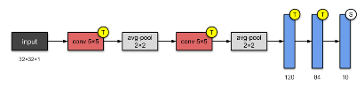 | It is one of the simplest architecture. | 2 – Convolutional layers  3 – Fully Connected Layers  Max Pooling Layers - sub-sampling layer | 60000
AlexNet | 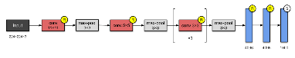 | It has 8 layers. It stacked a few more layers onto LeNet-5. They were the first to implement Rectified Linear Units (ReLUs) as activation functions. | 5 – Convolutional layers  3 – Fully Connected Layers  Max Pooling Layers - sub-sampling layer | 60M
GoogleNet | 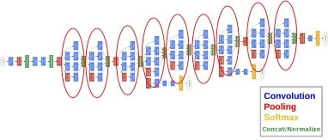 | It used batch normalization, image distortions and RMSprop. This module is based on several very small convolutions in order to drastically reduce the number of parameters. | 22 layer deep CNN | 4M
VGG -16 | 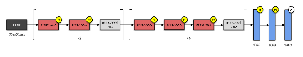 | This network stacks more layers onto AlexNet, and use smaller size filters (2×2 and 3×3. Activation layer is RELu | 13 – Convolutional layers  3 – Fully Connected Layers  5 - Max-pooling layers | 138M
VGG -19 |  | This network stacks more layers onto AlexNet, and use smaller size filters (2×2 and 3×3. Activation layer is RELu | 16 – Convolutional layers  3 – Fully Connected Layers  5 - Max-pooling layers | 144M
ResNet-50 | 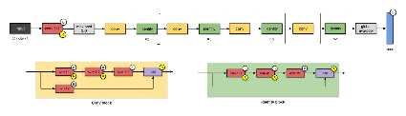 | ResNet is one of the early adopters of batch normalisation. | Upto 152 layers | 26M
DenseNet | 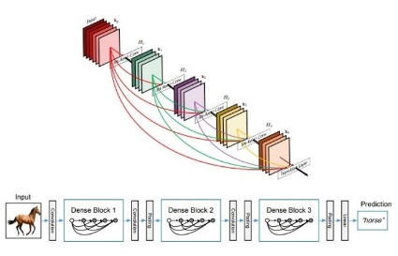 | Densenet have a single connection between consecutive layers, DenseNet ensures that each layer receives inputs from all preceding layers and passes its output to all subsequent layers. | Upto 256 Layers | 33M
ResNext-50 | 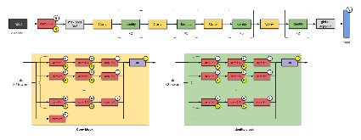 | ResNeXts is the adding of parallel towers/branches/paths within each module. |  | 25M
Channel Boosted CNN | 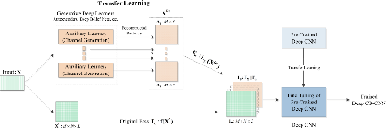 | The idea of Channel Boosting exploits both the channel dimension of CNN (learning from multiple input channels) and Transfer learning (TL)

